 |  | JURONG JUNIOR COLLEGE  JC 2 PRELIMINARY EXAMINATION  Higher 1
CANDIDATE
NAME

CLASS |  |  |  | EXAM INDEX NUMBER
CHEMISTRY |  |  |  |  | 8872/02
Paper 2 Structured Questions |  |  |  |  | 27 August 2010
 |  |  |  |  | 2 hours
Candidates answer Section A on the Question Paper.
Additional Materials: Answer Paper
Data Booklet
READ THESE INSTRUCTIONS FIRST
Write your name and class on all the work you hand in.
Write in dark blue or black pen on both sides of the paper.
You may use a soft pencil for any diagrams, graphs or rough working.
Do not use staples, paper clips, highlighters, glue or correction fluid.

A Data Booklet is provided. Do not write anything on the Data Booklet.

You are reminded of the need for good English and clear presentation in your answers.
Section A
Answer all questions.

Section B
Answer two questions on separate answer paper.

At the end of the examination, fasten all your work securely together.
The number of marks is given in brackets [ ] at the end of each question or part question.
 |  |  |  |  |  |  |  | For Examiner’s Use
 |  |  |  |  |  |  |  | Section A
 |  |  |  |  |  |  |  | B5
 |  |  |  |  |  |  |  | B6
 |  |  |  |  |  |  |  | B7
 |  |  |  |  |  |  |  | Total
This document consists of 15 printed pages and 1 blank page.
[Turn over
Section A

Answer all questions in this section in the spaces provided.

1. | (a) | A gaseous mixture of ¹⁶O, ¹⁶O⁺ and ¹⁶O²⁻ is passed through an electric field which is at right angles to their direction of travel. Sketch and label, on the diagram below how each beam of the 3 particles is affected by the electric field.  +  –  ¹⁶O,  ¹⁶O⁺,  ¹⁶O²⁻ |  | [3]
 | (b) | Oxygen reacts with non-metals of Period 3 to form oxides of different physical and chemical properties. Suggest the pH of the following two Period 3 oxides in water.  Write chemical equations to describe the reactions, if any, of these oxides with water to give the different pH values.  …………………………………………………………………………………..………  …………………………………………………………………………………..………  …………………………………………………………………………………..……… |  | [2]
  Compound | pH in water
  SiO₂
  P₄O₁₀
 | (c) | The graph below shows the variation in ionisation energies for the outermost 8 electrons in an atom of element X.  1 2 3 4 5 6 7 8  no. of electrons removed  log₁₀ IE
1. | (c) | (i) | State, giving reasons, the group that element X belongs to.  …………………………………………………………………………………..  …………………………………………………………………………………..  …………………………………………………………………………………..  …………………………………………………………………………………..  …………………………………………………………………………………..
 |  | (ii) | Hence, draw a dot-and-cross diagram for the compound formed between chlorine and element X. | [4]
 |  | [Total: 9]

2. | Solid aluminium chloride sublimes at 180ºC. In the vapour phase, an equilibrium is established between aluminium chloride and its dimer.  2AlCl₃(g)  Al₂Cl₆(g)
 | (a) | Draw a dot-and-cross diagram to show the bonding in the dimer, Al₂Cl₆. |  |  | [1]
 | (b) | With the aid of a diagram, state and explain whether AlCl₃ is a polar or non-polar molecule. |  |  | [2]
2. | (c) | Solid AlCl₃ dissolves readily in water to give aqueous Al³⁺ and Cl⁻ ions. The aqueous Al³⁺ ion hydrolyses in water to produce an acidic solution, as shown by the following equation:  [Al(H₂O)₆]³⁺ + H₂O  [Al(OH)(H₂O)₅]²⁺ + H₃O⁺
 |  | (i) | What are acids and bases according to Bronsted-Lowry theory?  …………………………………………………………………………………..  …………………………………………………………………………………..
 |  | (ii) | With reference to the equation given above, identify the acid and base, and their respective conjugate base and acid.  Acid : …………………………………………..  Conjugate base: …………………………………………..  Base : …………………………………………..  Conjugate acid: ………………………………………….. |  | [3]
 | (d) | The oxide of aluminium, Al₂O₃, however, is not soluble in water but reacts with acids and alkalis to form salt and water.  Give equations for the reactions that occur between:
 |  | (i) | Al₂O₃ and HCl(aq),
 |  | (ii) | Al₂O₃ and NaOH(aq) | [2]
 |  |  | [Total: 8]

3. | Compound A exhibits geometrical isomerism.  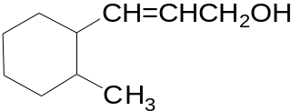  Compound A
 | (a) | Draw the geometrical isomers of compound A. |  | [2]
 | (b) | Draw the products formed when compound A reacts with the reagents indicated. Describe any observations, if any, made.
 |  | (i) | H₂, Pt catalyst, heat
 |  | (ii) | PCl₅, room temperature
 |  | (iii) | Cold, alkaline KMnO₄ | [5]
3. | (c) A reaction scheme involving compound A is shown below.  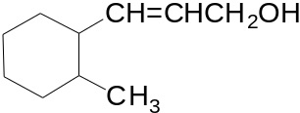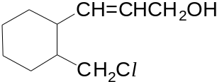  Compound  B  step I  step II  Hot acidified K₂Cr₂O₇(aq)  A
 |  | (i) | Suggest reagents and conditions for step I.  …………………………………………………………………………………..
 |  | (ii) | State the type of reaction for step II.  …………………………………………………………………………………..
 |  | (iii) | Draw the structure of compound B. | [3]
 |  |  | [Total: 10]
4. | The Olympic flame arrived in Singapore on August 6 2010 for a traditional six-day torch relay around the island before it was used to ignite the Singapore 2010 YOG cauldron to mark the start of the Game.  The fuel used to light the Olympic flame is propane gas which is also used in blow torches to melt bitumen needed to apply felt material to flat roofs and in outdoor flames such as patio heaters.  Most patio heaters are powered by the combustion of propane gas stored in small cylinders. A typical patio heater designed to produce 15 kW of energy runs from a cylinder containing 13 kg of propane. The standard enthalpy change of combustion of propane is −2220 kJ mol ^{–1}.  As pure propane gas is odourless, small amounts of another compound are usually added so that gas leaks from propane cylinders can be detected. An example of such an odorant is ethanethiol, C₂H₅SH; which has an odour that resembles that of onion. Ethanethiol is chosen since the human nose can detect its presence at levels of only about 0.02 moles of it per billion (10⁹) moles of propane.
 | (a) | A propane blow torch was used to heat 200 cm³ of water. Calculate the mass of propane needed to raise the temperature of water from 18.0°C to 68.5°C. |  | [2]
4. | (b) | Another value of the standard enthalpy change of combustion of propane, ΔH_{c}, can be calculated using bond energies and the energy cycle below.  3 C(g) + 8 H(g) + 10 O(g)  ΔH₁  +6460 kJ mol⁻¹  ΔH_{c}  C₃H₈(g) + 5O₂(g) 3CO₂(g) + 4H₂O(g)
 |  | (i) | Use suitable bond energies given in the Data Booklet to calculate ΔH₁.
 |  | (ii) | Hence, calculate ΔH_{c}.
 |  | (iii) | Give one reason why the value you calculated in (b)(ii) differs from the value for the enthalpy change of combustion of propane given in the passage.  …………………………………………………………………………………..  ………………………………………………………………………………….. | [3]
 | (c) | (i) | Calculate the total amount of heat energy released by the complete combustion of all the propane in a cylinder used in a patio heater.
 |  | (ii) | Calculate the rate at which propane must leave the cylinder (in cm³ s⁻¹) to produce 15 kW (i.e. 15 kJ s⁻¹). Assume that one mole of gas occupies 24 dm³. | [3]
4. | (d) | (i) | Draw a displayed formula to show the structure of ethanethiol and predict the bond angle around the sulfur atom.  Bond angle around sulfur atom: ………………………
 |  | (ii) | Predict and explain the difference in boiling points between ethanethiol and ethanol.  …………………………………………………………………………………..  …………………………………………………………………………………..  …………………………………………………………………………………..  …………………………………………………………………………………..  …………………………………………………………………………………..  …………………………………………………………………………………..
 |  | (iii) | Calculate the minimum mass of ethanethiol which must be added to 13 kg of propane so that it can be detected by the human nose in the event of a propane gas leak. | [5]
 |  |  | [Total:13]

BLANK PAGE

Section B

Answer two of the three questions in this section on separate answer paper.

5. | Elemental sodium, found in Period 3 of the Periodic Table, was first isolated by Sir Humphry Davy in 1807 by passing an electric current through molten sodium hydroxide. Elemental sodium does not occur naturally on Earth due to its high reactivity with air and water.
 | (a) | Write balanced equations to explain the words in italics. |  |  | [2]
 | (b) | (i) |  | State and explain the differences between sodium and chlorine in the following two physical properties:  - melting point  - electrical conductivity
 |  | (ii) |  | Describe, with an equation, the reaction between sodium metal and chlorine gas. Include state symbols in your answer.
 |  | (iii) |  | Predict, with reasoning, the pH of the resulting solution when your product in (b)(ii) is dissolved in water. | [6]
 | (c) | A student did a titration involving 0.100 mol dm^{–3} sodium hydroxide and 15 cm³ of CH₃COOH at 298K. The titration curve was obtained as follows.  pH  0  7  Volume of NaOH added / cm³  28  Y  x
 |  | (i) |  | With the aid of the titration curve, determine the initial concentration of CH₃COOH.
 |  | (ii) |  | State and explain the choice of indicator for the above titration.
 |  | (iii) |  | At point Y, the solution contains a mixture of CH₃COOH and CH₃COONa which resists pH changes when small amount of acid or base is added to it.  Using balanced equations, illustrate how the solution at point Y resists pH changes when small amount of acid or base is separately added to it. | [6]
5. | (d) | Sodium hydroxide is commonly used in organic synthesis for functional group conversions and acid–base reactions. The role of sodium hydroxide in organic reaction differs under different conditions.  Consider the following reaction scheme:  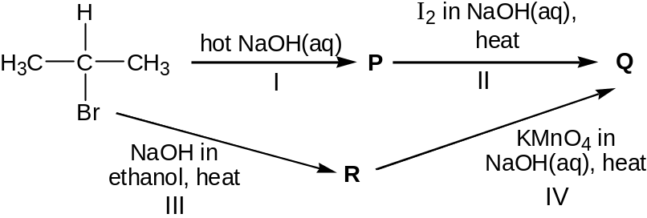
 |  | (i) | Suggest the structures of compounds P, Q and R.
 |  | (ii) | Suggest the type of reaction for reactions I to IV. |  | [6]
 |  |  | [Total: 20]

6. | Ethanol is an important industrial chemical and is usually made by the direct hydration of ethene.  C₂H₄(g) + H₂O(g)  CH₃CH₂OH(g) ΔH = −46 kJ mol⁻¹
 | (a) | (i) | Define the term standard enthalpy change of formation.
 |  | (ii) | Use the standard enthalpy change for the above reaction and the following enthalpy change of formation values, ΔH_{f}, given in the table below to calculate the enthalpy change of formation of gaseous ethanol.
  Compound | ΔH_{f}/kJ mol⁻¹
  C₂H₄(g) | 52.3
  H₂O(g) | −242
 |  | (iii) | Given that the standard enthalpy change of formation of liquid ethanol is −248 kJ mol⁻¹, calculate the enthalpy change for the conversion of one mole of liquid ethanol to one mole of gaseous ethanol at 298 K. | [4]
 | (b) | A 1.8 dm³ sealed vessel initially contained 1 mol of gaseous ethene and 3 mol of steam at 400 K and 1 atm. Upon reaching equilibrium, it was found that 27% of the ethene was converted to ethanol at 400 K.
 |  | (i) | Write an expression for the equilibrium constant, K_{c}, for the reaction.
 |  | (ii) | Using the data provided, calculate a value for K_{c} at 400 K.
 |  | (iii) | The percentage conversion of ethene to ethanol at equilibrium at various temperatures and pressures is shown below.  Temperature  % of ethene converted  3 atm  5 atm  9 atm  With reference to the graph above, explain the trend in the percentage of ethene converted with changes in  - temperature  - pressure | [7]
6. | (c) | A, B and C are isomeric alcohols with the molecular formula of C₄H₁₀O. On warming with acidified KMnO₄, the reagent does not change colour with A but decolourises with B and C, producing compounds D and E respectively. D gives an orange precipitate with 2,4-dinitrophenylhydrazine while E does not. When heated over Al₂O₃, A and C give the same alkene, F.  Suggest a structure for each lettered compound, and explain the reactions involved. |  | [9]
 |  |  | [Total: 20]

7. | This question is about food preservatives.
 | (a) | Cinnamaldehyde is a common carbonyl compound derivative used in the food industry. It can be used to synthesise compound H as shown in the following reaction scheme:  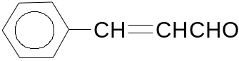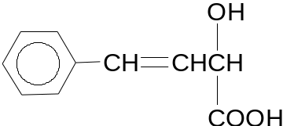  step I  step II  cinnamaldehyde  Compound H  Compound G
 |  | (i) | Draw the structure of the intermediate organic compound, G.
 |  | (ii) | State the reagents and conditions required for steps I and II.
 |  | (iii) | Describe a simple chemical test to distinguish between cinnamaldehyde and compound H. | [5]
 | (b) | Sulfur dioxide is sometimes used as a preservative for dried apricots and other dried fruits. As a preservative, it maintains the appearance of the fruit and prevents rotting.  In the laboratory, the presence of sulfur dioxide gas can be confirmed with an acidified solution of potassium dichromate(VI). Sulfur dioxide reacts with the Cr₂O₇²⁻ ions of potassium dichromate(VI) in the following way.  3SO₂(g) + Cr₂O₇²⁻(aq) + 2H⁺(aq) → 3SO₄²⁻(aq) + 2Cr³⁺(aq) + H₂O(l)
 |  | (i) | State the oxidation numbers of sulfur in SO₂ and SO₄²⁻.
 |  | (ii) | A gaseous sample of SO₂ was dissolved in 50 cm³ of potassium dichromate(VI) solution and was completely reacted. The resulting solution was found to contain 0.120 mol dm⁻³ of Cr³⁺(aq). Calculate the amount of sulfur dioxide dissolved.
 |  | (iii) | State what will be observed when the above reaction takes place. | [5]
 | (c) | Vanillin is used widely as a flavoring, usually in sweet foods such as ice cream and chocolate. It exists as a yellow solid and dissolves readily in water to form a yellow solution.  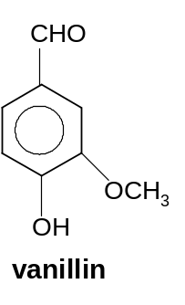  OCH₃  vanillin

7. | (c) | The kinetics of the reaction between vanillin and HCN were investigated using two different initial concentration of HCN. Both experiments were conducted at 25ºC in a pH 9.0 buffer.
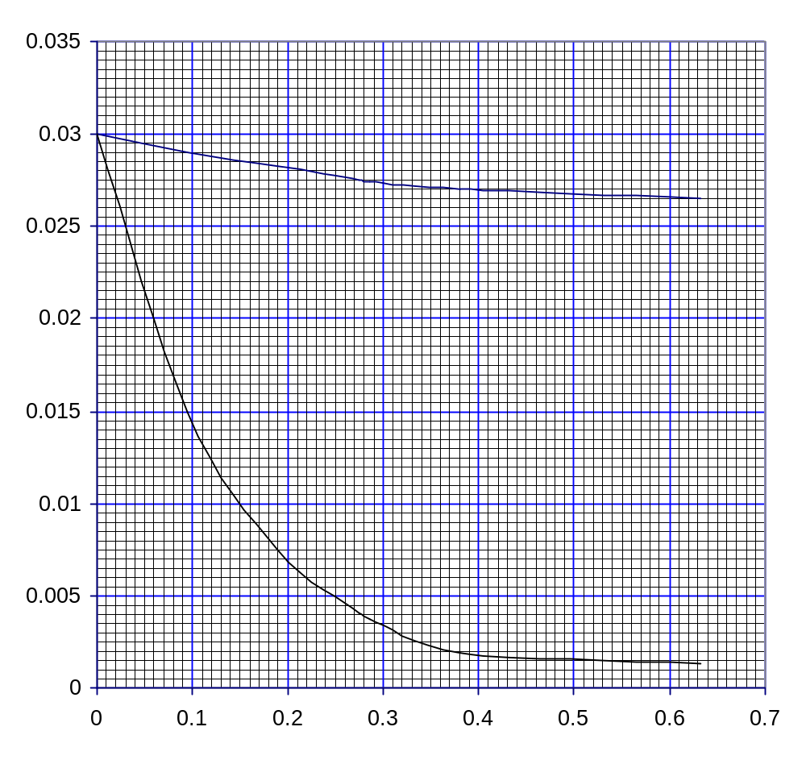
[HCN] = 5.00 mol dm⁻³
Time/ min
[HCN] = 0.100 mol dm⁻³
[vanillin]/ mol dm⁻³
 |  | (i) |  | Assuming that the reaction produces a colourless product, suggest one plausible method by which the concentration of vanillin may be followed during the course of the reaction.
 |  | (ii) |  | From the graph, deduce the order of the reaction with respect to vanillin. Give your reasoning.
 |  | (iii) |  | In the experiment using 0.100 mol dm⁻³ HCN, the half-life of the reaction is 4.75 min. Hence determine, with explanation, the order of reaction with respect to HCN.
 |  | (iv) |  | Hence, write down the rate equation for the reaction between vanillin and HCN. State the units for the rate constant.
 |  | (v) |  | With the help of a Boltzmann distribution diagram, explain how the addition of a catalyst speeds up the rate of the reaction. | [10]
 |  |  | [Total: 20]

